Circular Motion and Gravitation
NEWTON’S FIRST LAW TELLS US THAT objects will move in a straight line at a constant speed unless a net force is acting upon them. That rule would suggest that objects moving in a circle—whether they’re tetherballs or planets—are under the constant influence of a changing force, since their trajectory is not in a straight line. We will begin by looking at the general features of circular motion and then move on to examine gravity, one of the principal sources of circular motion.

Uniform Circular Motion
Uniform circular motion occurs when a body moves in a circular path with constant speed. For example, say you swing a tethered ball overhead in a circle:
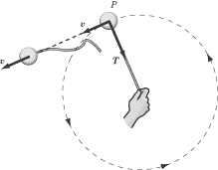
If we leave aside gravity for the moment, the only force acting on the ball is the force of tension, T, of the string. This force is always directed radially inward along the string, toward your hand. In other words, the force acting on a tetherball traveling in a circular path is always directed toward the center of that circle.
Note that although the direction of the ball’s velocity changes, the ball’s velocity is constant in magnitude and is always tangent to the circle.
Centripetal Acceleration
From kinematics, we know that acceleration is the rate of change of the velocity vector with time. If we consider two points very close together on the ball’s trajectory and calculate , we find that the ball’s acceleration points inward along the radius of the circle.
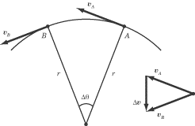
The acceleration of a body experiencing uniform circular motion is always directed toward the center of the circle, so we call that acceleration centripetal acceleration, . Centripetal comes from a Latin word meaning “center-seeking.” We define the centripetal acceleration of a body moving in a circle as:
where v is the body’s velocity, and r is the radius of the circle. The body’s centripetal acceleration is constant in magnitude but changes in direction. Note that even though the direction of the centripetal acceleration vector is changing, the vector always points toward the center of the circle.
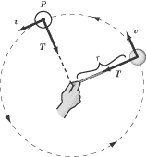
How This Knowledge Will Be Tested
Most of us are accustomed to think of “change” as a change in magnitude, so it may be counterintuitive to think of the acceleration vector as “changing” when its magnitude remains constant. You’ll frequently find questions on SAT II Physics that will try to catch you sleeping on the nature of centripetal acceleration. These questions are generally qualitative, so if you bear in mind that the acceleration vector is constant in magnitude, has a direction that always points toward the center of the circle, and is always perpendicular to the velocity vector, you should have no problem at all.
Centripetal Force
Wherever you find acceleration, you will also find force. For a body to experience centripetal acceleration, a centripetal force must be applied to it. The vector for this force is similar to the acceleration vector: it is of constant magnitude, and always points radially inward to the center of the circle, perpendicular to the velocity vector.
We can use Newton’s Second Law and the equation for centripetal acceleration to write an equation for the centripetal force that maintains an object’s circular motion:
EXAMPLE
A ball with a mass of 2 kg is swung in a circular path on a massless rope of length 0.5 m. If the ball’s speed is 1 m/s, what is the tension in the rope?

The tension in the rope is what provides the centripetal force, so we just need to calculate the centripetal force using the equation above:

Objects Released from Circular Motion
One concept that is tested frequently on SAT II Physics is the trajectory of a circling body when the force providing centripetal acceleration suddenly vanishes. For example, imagine swinging a ball in a circle overhead and then letting it go. As soon as you let go, there is no longer a centripetal force acting on the ball. Recall Newton’s First Law: when no net force is acting on an object, it will move with a constant velocity. When you let go of the ball, it will travel in a straight line with the velocity it had when you let go of it.
EXAMPLE
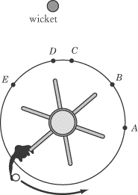
A student is standing on a merry-go-round that is rotating counterclockwise, as illustrated above. The student is given a ball and told to release it in such a way that it knocks over the wicket at the top of the diagram. At what point should the student release the ball?

When the student releases the ball, it will travel in a straight line, tangent to the circle. In order to hit the wicket, then, the student should release the ball at point B.
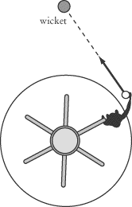

Newton’s Law of Universal Gravitation
Newton’s Law of Universal Gravitation is a fundamental physical law. We experience its effects everywhere on this planet, and it is the prime mover in the vast world of astronomy. It can also be expressed in a relatively simple mathematical formula on which SAT II Physics is almost certain to test you.
Gravitational Force
In 1687, Isaac Newton published his Law of Gravitation in Philosophiae Naturalis Principia Mathematica. Newton proposed that every body in the universe is attracted to every other body with a force that is directly proportional to the product of the bodies’ masses and inversely proportional to the square of the bodies’ separation. In terms of mathematical relationships, Newton’s Law of Gravitation states that the force of gravity, , between two particles of mass and has a magnitude of:
where r is the distance between the center of the two masses and G is the gravitational constant. The value of G was determined experimentally by Henry Cavendish in 1798:
The force of gravity is a vector quantity. Particle attracts particle with a force that is directed toward , as illustrated in the figure below. Similarly, particle attracts particle with a force that is directed toward .
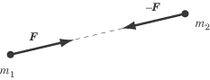
Note that the gravitational force, , acting on particle is equal and opposite to the gravitational force acting on particle , –. This is a consequence of Newton’s Third Law.
Let’s consider two examples to give you a more intuitive feel for the strength of the gravitational force. The force of gravity between two oranges on opposite sides of a table is quite tiny, roughly 10–13 N. On the other hand, the gravitational force between two galaxies separated by 106 light years is something in the neighborhood of 1027 N!
Newton’s Law of Gravitation was an enormous achievement, precisely because it synthesized the laws that govern motion on Earth and in the heavens. Additionally, Newton’s work had a profound effect on philosophical thought. His research implied that the universe was a rational place that could be described by universal, scientific laws. But this is knowledge for another course. If you are interested in learning more about it, make sure to take a class on the history of science in college.
Gravity on the Surface of Planets
Previously, we noted that the acceleration due to gravity on Earth is 9.8 m/s2 toward the center of the Earth. We can derive this result using Newton’s Law of Gravitation.
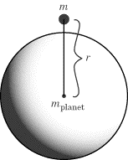
Consider the general case of a mass accelerating toward the center of a planet. Applying Newton’s Second Law, we find:

Note that this equation tells us that acceleration is directly proportional to the mass of the planet and inversely proportional to the square of the radius. The mass of the object under the influence of the planet’s gravitational pull doesn’t factor into the equation. This is now pretty common knowledge, but it still trips up students on SAT II Physics: all objects under the influence of gravity, regardless of mass, fall with the same acceleration.
Acceleration on the Surface of the Earth
To find the acceleration due to gravity on the surface of the Earth, we must substitute values for the gravitational constant, the mass of the Earth, and the radius of the Earth into the equation above:

Not coincidentally, this is the same number we’ve been using in all those kinematic equations.
Acceleration Beneath the Surface of the Earth
If you were to burrow deep into the bowels of the Earth, the acceleration due to gravity would be different. This difference would be due not only to the fact that the value of r would have decreased. It would also be due to the fact that not all of the Earth’s mass would be under you. The mass above your head wouldn’t draw you toward the center of the Earth—quite the opposite—and so the value of would also decrease as you burrowed. It turns out that there is a linear relationship between the acceleration due to gravity and one’s distance from the Earth’s center when you are beneath the surface of the Earth. Burrow halfway to the center of the Earth and the acceleration due to gravity will be 1/2 g. Burrow three-quarters of the way to the center of the Earth and the acceleration due to gravity will be 1 /4 g.
Orbits
The orbit of satellites—whether of artificial satellites or natural ones like moons and planets—is a common way in which SAT II Physics will test your knowledge of both uniform circular motion and gravitation in a single question.
How Do Orbits Work?
Imagine a baseball pitcher with a very strong arm. If he just tosses the ball lightly, it will fall to the ground right in front of him. If he pitches the ball at 100 miles per hour in a line horizontal with the Earth, it will fly somewhere in the neighborhood of 80feet before it hits the ground. By the same token, if he were to pitch the ball at 100,000miles per hour in a line horizontal with the Earth, it will fly somewhere in the neighborhood of 16 miles before it hits the ground. Now remember: the Earth is round, so if the ball flies far enough, the ball’s downward trajectory will simply follow the curvature of the Earth until it makes a full circle of the Earth and hits the pitcher in the back of the head. A satellite in orbit is an object in free fall moving at a high enough velocity that it falls around the Earth rather than back down to the Earth.
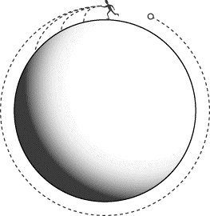
Gravitational Force and Velocity of an Orbiting Satellite
Let’s take the example of a satellite of mass orbiting the Earth with a velocity v. The satellite is a distance R from the center of the Earth, and the Earth has a mass of .
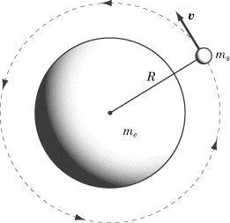
The centripetal force acting on the satellite is the gravitational force of the Earth. Equating the formulas for gravitational force and centripetal force we can solve for v:

As you can see, for a planet of a given mass, each radius of orbit corresponds with a certain velocity. That is, any object orbiting at radius R must be orbiting with a velocity of . If the satellite’s speed is too slow, then the satellite will fall back down to Earth. If the satellite’s speed is too fast, then the satellite will fly out into space.

Gravitational Potential Energy
In Chapter 4, we learned that the potential energy of a system is equal to the amount of work that must be done to arrange the system in that particular configuration. We also saw that gravitational potential energy depends on how high an object is off the ground: the higher an object is, the more work needs to be done to get it there.
Gravitational potential energy is not an absolute measure. It tells us the amount of work needed to move an object from some arbitrarily chosen reference point to the position it is presently in. For instance, when dealing with bodies near the surface of the Earth, we choose the ground as our reference point, because it makes our calculations easier. If the ground is h = 0, then for a height h above the ground an object has a potential energy of mgh.
Gravitational Potential in Outer Space
Off the surface of the Earth, there’s no obvious reference point from which to measure gravitational potential energy. Conventionally, we say that an object that is an infinite distance away from the Earth has zero gravitational potential energy with respect to the Earth. Because a negative amount of work is done to bring an object closer to the Earth, gravitational potential energy is always a negative number when using this reference point.
The gravitational potential energy of two masses, and , separated by a distance r is:
EXAMPLE
A satellite of mass is launched from the surface of the Earth into an orbit of radius , where is the radius of the Earth. How much work is done to get it into orbit?

The work done getting the satellite from one place to another is equal to the change in the satellite’s potential energy. If its potential energy on the surface of the Earth is and its potential energy when it is in orbit is , then the amount of work done is:

Energy of an Orbiting Satellite
Suppose a satellite of mass is in orbit around the Earth at a radius R. We know the kinetic energy of the satellite is KE = 1/2 mv2. We also know that we can express centripetal force, , as = mv2/R. Accordingly, we can substitute this equation into the equation for kinetic energy and get:
Because is equal to the gravitational force, we can substitute Newton’s Law of Universal Gravitation in for :
We know that the potential energy of the satellite is , so the total energy of the satellite is the sum, E = KE + U:

Weightlessness
People rarely get to experience firsthand the phenomenon of weightlessness, but that doesn’t keep SAT II Physics from testing you on it. There is a popular misconception that astronauts in satellites experience weightlessness because they are beyond the reach of the Earth’s gravitational pull. If you already know this isn’t the case, you’re in a good position to answer correctly anything SAT II Physics may ask about weightlessness.
In order to understand how weightlessness works, let’s look at the familiar experience of gaining and losing weight in an elevator. Suppose you bring a bathroom scale into the elevator with you to measure your weight.
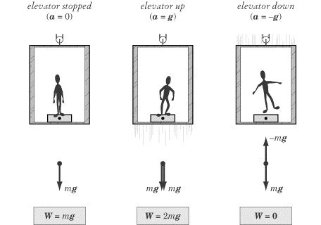
When the elevator is at rest, the scale will read your usual weight, W = mg, where m is your mass. When the elevator rises with an acceleration of g, you will be distressed to read that your weight is now m(g + g) = 2mg. If the elevator cable is cut so that the elevator falls freely with an acceleration of –g, then your weight will be m(g – g) = 0.
While in free fall in the elevator, if you were to take a pen out of your pocket and “drop” it, it would just hover in the air next to you. You, the pen, and the elevator are all falling at the same rate, so you are all motionless relative to one another. When objects are in free fall, we say that they experience weightlessness. You’ve probably seen images of astronauts floating about in space shuttles. This is not because they are free from the Earth’s gravitational pull. Rather, their space shuttle is in orbit about the Earth, meaning that it is in a perpetual free fall. Because they are in free fall, the astronauts, like you in your falling elevator, experience weightlessness.
Weightless environments provide an interesting context for testing Newton’s Laws. Newton’s First Law tells us that objects maintain a constant velocity in the absence of a net force, but we’re so used to being in an environment with gravity and friction that we never really see this law working to its full effect. Astronauts, on the other hand, have ample opportunity to play around with the First Law. For example, say that a weightless astronaut is eating lunch as he orbits the Earth in the space station. If the astronaut releases his grasp on a tasty dehydrated strawberry, then the berry, like your pen, floats in midair exactly where it was “dropped.” The force of gravity exerted by the Earth on the strawberry causes the strawberry to move in the same path as the spaceship. There is no relative motion between the astronaut and the berry unless the astronaut, or something else in the spaceship, exerts a net force on the berry.

Kepler’s Laws
After poring over the astronomical observations of his mentor Tycho Brahe (1546–1601), Johannes Kepler (1571–1630) determined three laws of planetary motion. These laws are of great significance, because they formed the background to Newton’s thinking about planetary interaction and the attraction between masses. In fact, Newton later showed that Kepler’s Laws could be derived mathematically from his own Law of Universal Gravitation and laws of motion, providing evidence in favor of Newton’s new theories. Another point in favor of their significance is that any one of them may appear on SAT II Physics.
Kepler’s First Law states that the path of each planet around the sun is an ellipse with the sun at one focus.
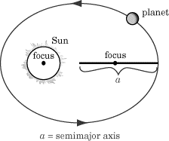
Kepler’s Second Law relates a planet’s speed to its distance from the sun. Because the planets’ orbits are elliptical, the distance from the sun varies. The Second Law states that if a line is drawn from the sun to the orbiting planet, then the area swept out by this line in a given time interval is constant. This means that when the planet is farthest from the sun it moves much more slowly than when it is closest to the sun.

